Congo, Dem. Rep.

## GNI per capita and development level

The data set shows the GNI per capita and development level of the country each year.

## # A tibble: 19 x 5  
## country iso3c date GNIperCapita devCategory  
## <chr> <chr> <dbl> <dbl> <chr>   
## 1 Congo, Dem. Rep. ZAR 1996 366. Low Income   
## 2 Congo, Dem. Rep. ZAR 1998 324. Low Income   
## 3 Congo, Dem. Rep. ZAR 2000 285. Low Income   
## 4 Congo, Dem. Rep. ZAR 2002 268. Low Income   
## 5 Congo, Dem. Rep. ZAR 2003 276. Low Income   
## 6 Congo, Dem. Rep. ZAR 2004 284. Low Income   
## 7 Congo, Dem. Rep. ZAR 2005 289. Low Income   
## 8 Congo, Dem. Rep. ZAR 2006 297. Low Income   
## 9 Congo, Dem. Rep. ZAR 2007 304. Low Income   
## 10 Congo, Dem. Rep. ZAR 2008 304. Low Income   
## 11 Congo, Dem. Rep. ZAR 2009 310. Low Income   
## 12 Congo, Dem. Rep. ZAR 2010 320. Low Income   
## 13 Congo, Dem. Rep. ZAR 2011 327. Low Income   
## 14 Congo, Dem. Rep. ZAR 2012 335. Low Income   
## 15 Congo, Dem. Rep. ZAR 2013 337. Low Income   
## 16 Congo, Dem. Rep. ZAR 2014 359. Low Income   
## 17 Congo, Dem. Rep. ZAR 2015 378. Low Income   
## 18 Congo, Dem. Rep. ZAR 2016 399. Low Income   
## 19 Congo, Dem. Rep. ZAR 2017 397. Low Income

## GDP growth and economic growth classification

The data set shows the GDP growth and the ecomic growth classification of the country each year.

## # A tibble: 19 x 5  
## country iso3c date GDPannualGrowthRate GDPgrowthCategory4  
## <chr> <chr> <dbl> <dbl> <fct>   
## 1 Congo, Dem. Rep. ZAR 1996 -1.02 negative grwoth   
## 2 Congo, Dem. Rep. ZAR 1998 -1.62 negative grwoth   
## 3 Congo, Dem. Rep. ZAR 2000 -6.91 negative grwoth   
## 4 Congo, Dem. Rep. ZAR 2002 2.95 moderate growth   
## 5 Congo, Dem. Rep. ZAR 2003 5.58 fast growth   
## 6 Congo, Dem. Rep. ZAR 2004 6.74 fast growth   
## 7 Congo, Dem. Rep. ZAR 2005 6.14 fast growth   
## 8 Congo, Dem. Rep. ZAR 2006 5.32 moderate growth   
## 9 Congo, Dem. Rep. ZAR 2007 6.26 fast growth   
## 10 Congo, Dem. Rep. ZAR 2008 6.23 fast growth   
## 11 Congo, Dem. Rep. ZAR 2009 2.86 moderate growth   
## 12 Congo, Dem. Rep. ZAR 2010 7.11 fast growth   
## 13 Congo, Dem. Rep. ZAR 2011 6.87 fast growth   
## 14 Congo, Dem. Rep. ZAR 2012 7.09 fast growth   
## 15 Congo, Dem. Rep. ZAR 2013 8.48 fast growth   
## 16 Congo, Dem. Rep. ZAR 2014 9.47 fast growth   
## 17 Congo, Dem. Rep. ZAR 2015 6.92 fast growth   
## 18 Congo, Dem. Rep. ZAR 2016 2.40 slow growth   
## 19 Congo, Dem. Rep. ZAR 2017 3.73 moderate growth

## Development trend

The plot shows the development trend of the country.

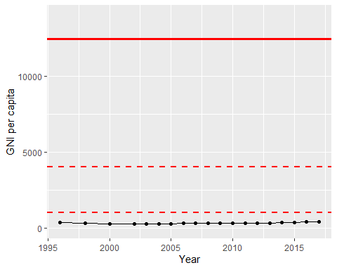

GNI Per Capita Trend